ROB 101

Computational Linear Algebra

Homework 1

Read Chapter 1 of our ROB 101 Booklet, Notes for Computational Linear Algebra; you will find a copy on

our Canvas site, in the file folder. Based on your reading of the Chapter, summarize in your own words:

(a) the purpose of the Chapter;

(b) two things you found the most interesting.

Solution:

Purpose – The chapter begins off with a central concept of algebra i.e. quadratic equations. Then we talk about different numbers and stuff. Finally, we are introduced to the notion of solving linear equations and the problems of solving them manually. Then, we are shown the real-world applications of linear algebra and how being able to solve huge systems of equations is helpful.

Two things which I found most interesting:

1. The generalized notation for variables. People may not realize the importance of this but having a generalized notation makes stuff less messy and easy to understand.
2. The real-world application of linear equations of linear algebra from creating a map for robot to helping a bipedal robot balance itself.

2. Lines in the plane

(a) On a single graph, with horizontal axis x and vertical axis y, sketch the two lines y = 0.5x + 1 and y = -x + 4. Find a

point (x*; y*) where they cross one another (read the values as closely as you can from the graph, say to an accuracy of

+- 0.5). Is there more than one point on the plane where the two lines cross?

(b) Optional (means you are not required to work this part): Can you relate the point you found to the following system of

linear equations?

x - 2y = -2

x + y = 4

(c) Remark: Sketching the graphs by hand is perfectly fine and is what we expect most of you to do. It is also OK to make

the plots using Julia or any other software package. Hand sketched plots will receive the same marks as a computer

generated plot.

Solution: (a) We plot a graph to search for solution

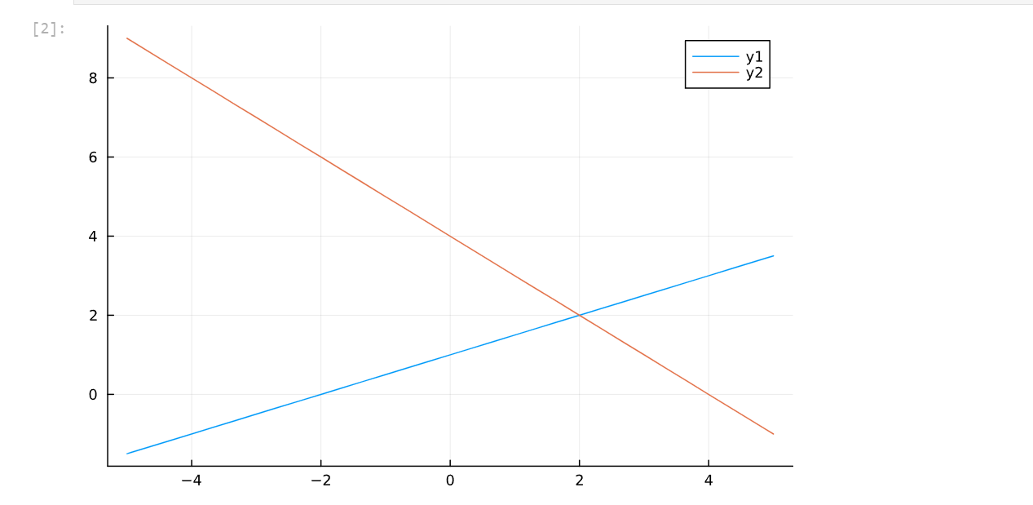

We get (2,2) as one and only solution for the system of linear equations.

(b) As for, x - 2y = -2 and x + y = 4, Let's put int the values,

In equation 1, LHS = 2 – 2*2 = -2 = RHS

In equation 2, LHS = 2 + 2 = 4 = RHS.

Hence (2,2) satisfies both the systems of equations.

**Key: A matter of fact is both the systems of equations are same.**

y = 0.5 x + 1 => 0.5 x – y = -1 (shifting terms does not change equation)

=> 2*(0.5 x – y) = 2*-1 => x – 2y = -2 (Multiplying both sides do not change the equation.)

3. Lines in the plane

(a) On a single graph, with horizontal axis x and vertical axis y, sketch the two lines y = 2x + 1 and y = 2x + 4. Can you

find a point (x*; y*) where they cross one another (read the values as closely as you can from the plot, say to an accuracy

of *0:5)? If you cannot find a point where the two lines intersect, explain why not.

(b) Optional: Can you relate the results of your graph to the following system of linear equations?

2x - y = -1

-x + ½y = 2

Solution: (a) We plot the graph to search for solution

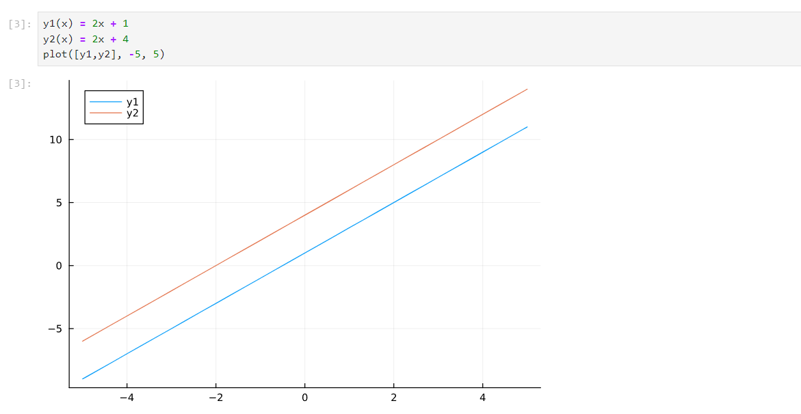

We see that both lines are parallel and have no solution i.e. for all values of x, y1 and y2 will have different values.

(b)

2x - y = -1 => 2x + 1 = y => y = 2x + 1

-x + ½y = 2 => 1/2y = 2 + x => y = 2x + 4

The system of equations is the same as that in (a). So, graph tells no solution for system of equations mentioned in (b).

4. Plot the graph of the quadratic equation y = 2x2+x-4, for -3 <= x <= 3. From the graph, approximately find the two values

of x where y = 0. Repeat for y = 2. (read the values as closely as you can from the plot, say to an accuracy of +-0.25)

Solution: Lets first plot the curve for y = 2x2 + x- 4 with line y = 0.

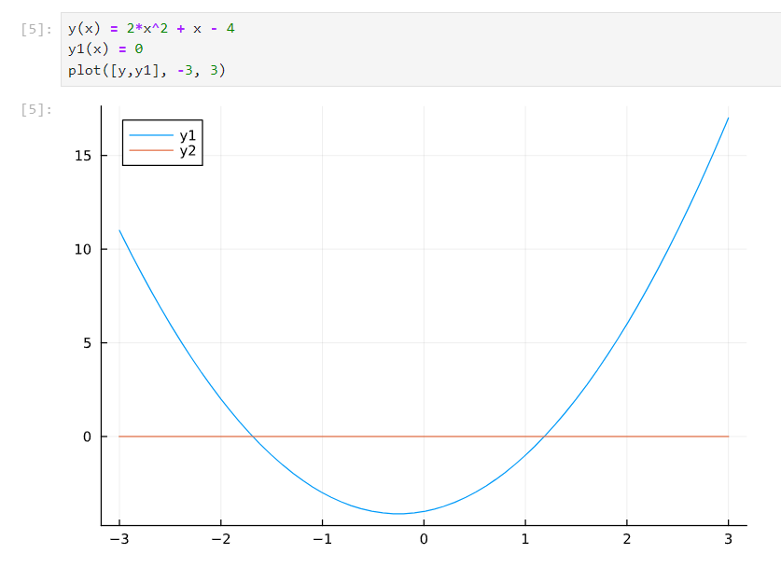

From graph, we can see two values where curve has value y = 0 which are (-1.7, 0) and (1.2,0) approximately.

Now, let's plot the curve with line y = 2.

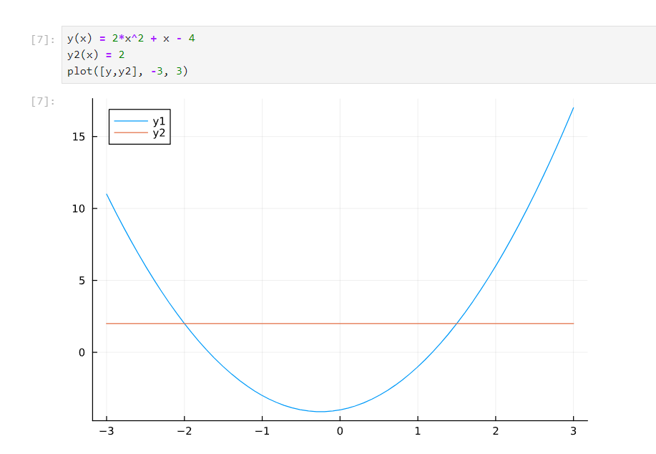From graph, we can see two values where curve has value y = 0 which are (-2, 2) and (1.5,0) approximately.

5. Consider the equation 2x2 + 3x - 2 = 0

(a) Evaluate its discriminant (see Chapter 1 or the Hints)

(b) You should have found that the discriminant is positive and hence the equation has two real solutions. Compute them using the quadratic formula (see Chapter 1 or the Hints).

Solution:

1. Let’s calculate the value of discriminants.

Discriminant = b2 – 4ac = 3*3 – 4*2*-2 = 9 + 16 = 25

(b) x = (-b +- (disc)^0.5)/(2*a)

X1 = (-3 + 5)/ (2*2) = 0.5

X2 = (-3 –5)/ (2*2) = -2

So, Solutions of quadratic equations are 0.5 and –2.

6. Consider a system of linear equations with two unknowns

y - 4z = 2

2y - 10z = -2

(a) Solve the system of equations. Show all the steps when determining your solution. You do not need to generate a plot.

(b) Write the system in the form Ax = b, where you clearly identify A, x, and b. This will require some material from

Chapter 2; see also the Hints.

Solution:

First equation:

y– 4z = 2

2y – 10z = -2 => y – 5z = -1

-4z + 5z = 2 + 1 => z = 3.

Y= 4z + 2 = 4*3 + 2 = 14

[y z] = [14 3] is a solution to system of equations.

A = [1 –4; 2 –10] x = [y; z] b = [2; -2]

End of Assignment